This is document A.

{{Todays Date}}

{{Bank Name}}

{{Bank address line 1}}

{{Bank address line 2}}

{{Bank address line 3}}

{{Bank address line 4}}

Subject: Letter of Employment Verification for {{Employee Name}}

To Whom It May Concern,

I am writing this letter to confirm that {{Employee’s Name}} is currently employed at Acme Inc. as a {{Job Title}}. They started working with us on {{Start Date}}.

{{Employee’s Name}} is a permanent member of staff, working on a full time basis and receives a salary of ${{salary}}.

Please do not hesitate to contact us at {{Contact Number}} if you require any further information.

Sincerely,

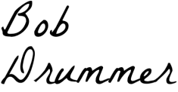

Bob Drummer

CHRO

Acme Inc.